Writing Refresher Series Announcement
The Writing Center has a series of writing skills refreshers to improve any student’s level of writing, from basic writing, business and professional writing, to graduate writing.
To post the below announcement in your class or as part of your instructor guidance, create a new announcement, and click on the “HTML Editor.” Then copy and paste the HTML code shown below:
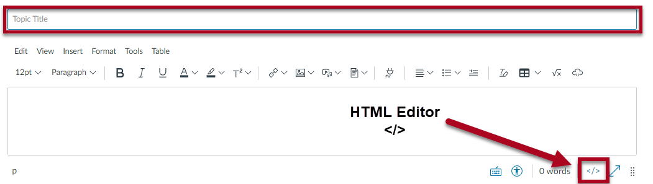

Announcement Message as it Will Appear When Using the HTML Code Below:

Subject: Writing Skills Refresher Series
Hi Class,
Writing is a skill that even expert writers continually improve. To improve your academic and professional writing, it’s important to use guides that will help you to become a more effective writer.
Use the Writing Center’s Writing Skills Refresher (Links to an external site.) series to help writing feel a little easier.
Visit other great writing resources on the Writing Center website (Links to an external site.).

HTML Code for the Announcement:
<p>Hi Class,</p>
<p>Writing is a skill that even expert writers <strong>continually improve</strong>. To improve your academic and professional writing, it&rsquo;s important to use guides that will help you to <strong>become a more effective writer</strong>.</p>
<p>Use the Writing Center&rsquo;s <a href="https://writingcenter.uagc.edu/writing-skills-refreshers">Writing Skills Refresher</a> series to help writing feel a little easier.</p>
<p><img src="https://ashford.instructure.com/users/120844/files/9716209/preview?verifier=4AmdFf4uVZAMUZhZB16TJKX6oY39jgkU562hTVGb" alt="brain-storming.jpg" width="300" height="300" data-api-endpoint="https://ashford.instructure.com/api/v1/users/120844/files/9716209" data-api-returntype="File" /></p>
<p>Visit other great writing resources on the <a href="https://writingcenter.uagc.edu/">Writing Center website</a>.</p>

Need help posting the HTML code? Watch this helpful video!

